Title in English (Times New Roman; size-12; Interline 1,15)

Full name of the first author ¹, Full name of the second author ²
¹ Full affiliation, Email address, (Times New Roman; size-12)
² Full affiliation, Email address, (times new roman; size-12)

Received: .../…/2019 Accepted: .../…/2019 Published:.../…/2019

Abstract: (Not more than 08 lines)
Enter your abstract here (an abstract is a brief, comprehensive summary of the contents of the article). Enter your abstract here (an abstract is a brief, comprehensive summary of the contents of the article). Enter your abstract here (an abstract is a brief, comprehensive summary of the contents of the article).
Enter your abstract here (an abstract is a brief, comprehensive summary of the contents of the article). Enter your abstract here (an abstract is a brief, comprehensive summary of the contents of the article).
Keywords: keywords; keywords; keywords; keywords; keywords.
Jel Classification Codes: : …, …, …

__________________________________________

Corresponding author: Full name, e-mail: authorC@mail.com.

1. INTRODUCTION

2. First Subtitle
The first subtitle opens with an introduction that presents the specific problem under study and describes the research strategy. The first subtitle opens with an introduction that presents the specific problem under study and describes the research strategy. The first subtitle opens with an introduction that presents the specific problem under study and describes the research strategy.
3. Second Subtitle
Enter here the text of second subtitle, enter here the text of second subtitle, enter here the text of second subtitle, enter here the text of second subtitle, enter here the text of second subtitle, enter here the text of second subtitle, enter here the text of second subtitle, enter here the text of second subtitle, enter here the text of second subtitle, enter here the text of second subtitle, enter here the text of second subtitle, enter here the text of second subtitle, enter here the text of second subtitle.

4. RESULTS AND DISCUSSION
Enter your results in this section; summarize the collected data and the analysis performed on those data relevant to the discourse that is to follow. After presenting the results, you are in a position to evaluate and interpret their implications, especially with respect to your original hypotheses.

Table 1. Table title (this is an example of table 1)
Test 1 | Test 2 | Results 1 | Results 2 | Total Results

Source:

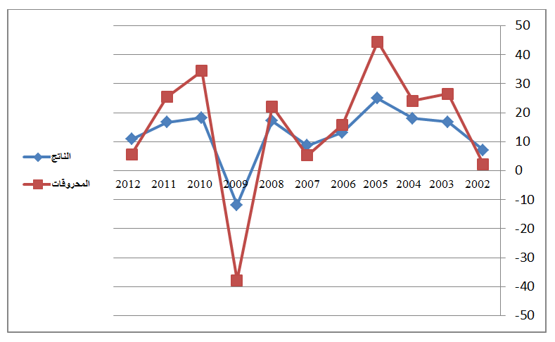
Fig.1. Figure title (this is an example of figure 1)

Source:

3. EXPERIMENTAL
This experimental section can be divided into subsections, the contents of which vary according to the subject matter of the article. It must contain all the information about the experimental procedure and materials used to carry out experiments.

4. CONCLUSION
The conclusion of a research paper needs to summarize the content and purpose of the article. The conclusion of a research paper needs to summarize the content and purpose of the article. The conclusion of a research paper needs to summarize the content and purpose of the article. The conclusion of a research paper needs to summarize the content and purpose of the article. The conclusion of a research paper needs to summarize the content and purpose of the article. The conclusion of a research paper needs to summarize the content and purpose of the article.

5. Bibliography List :
Use the « APA Reference System », see the link :

https://www.youtube.com/watch?v=AmiKblUQs_A

The references must be directly quoted in the body of the text (eg: ... (Brown, 2006, p35), without omitting to mention the complete reference in the list of references at the end of the document, written in the following manner: (Times New Roman12 interligne 1.15)
- Books : author’s name (year), full title, publishing, country;
- Theses: researcher, thesis title, college, university, country, year;
- Journal article : author’s name (year), full title of the article, review name, place, volume and number ;
- Seminar article: author’s name (year), full title of the paper, title of seminar, place and date, country ;
- Internet websites: author’s name (year), full title of the file, detailed web site : http://fulladdress (consulted on day/month/year).

6. Appendices

