PEOPLE’S DEMOCRATIC REPUBLIC OF ALGERIA

MINISTRY OF HIGHER EDUCATION AND SCIENTIFIC RESEARCH

UNIVERSITY OF MOHAMED BOUDIAF - M’SILA

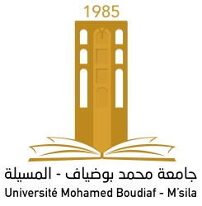

FACULTY OF Letters and LAnguages

DEPARTMENT OF ENGLISH

N°:………………………………………..
DOMAIN: FOREIGN LANGUAGES
STREAM: ENGLISH Language
OPTION: LiNGUISTICS

Your Dissertation Title,
(in Bold type; Arial Font ; Size 20)

Dissertation Submitted to the Department of English in Partial fulfillment of the Requirements for the Master’s Degree

Candidates:
……………………………….

Board of Examiners

Mrs. …………………….. | University of M’sila | Chairperson
Mr. …………………….. | University of M’sila | Supervisor
Mr. …………………….. | University of M’sila | Examiner

2023

