**PEOPLE’S DEMOCRATIC REPUBLIC OF ALGERIA**

**MINISTRY OF HIGHER EDUCATION AND SCIENTIFIC RESEARCH**

**UNIVERSITY OF MOHAMED BOUDIAF - M’SILA**

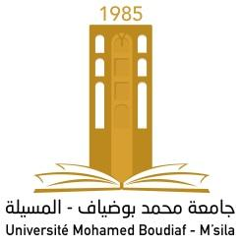



**Dissertation Submitted to the Department of English in Partial fulfillment of the Requirements for the Master’s Degree**

**Candidates:**

**……………………………….**

**Board of Examiners**

| Mrs. …………………….. | University of M’sila | Chairperson |
| --- | --- | --- |
| Mr. …………………….. | University of M’sila | Supervisor |
| Mr. …………………….. | University of M’sila | Examiner |

**2023**