[Your Paper Title Here]

Author Name(s)
Author Affiliation(s)
Author Email Address(es)

Abstract
A comprehensive and concise summary of your research, covering the introduction, problem statement, methodology, experimental results, key findings, and overall contributions to the field. The abstract should clearly outline the background and context of the study, highlighting the motivation behind the research and the specific challenges or gaps it aims to address. It should define the problem statement in a precise manner, explaining why the issue is important and how it relates to current developments in measurement and sensor technology.
Finally, the abstract should underline the main contributions of the work, whether theoretical, methodological, or practical, and explain its significance and potential applications in real-world measurement and sensor systems. As a standalone section, it should provide readers with a clear understanding of the purpose, approach, outcomes, and impact of the research without requiring reference to the full document.
Keywords: [Keyword 1, Keyword 2, Keyword 3, Keyword 4]

Figures and Illustrations
A schematic block diagram of the proposed ultra-low-power multi-node wireless sensor system, illustrating the central gateway, autonomous mesh nodes, individual sensor modules (e.g., CO, PM2.5, Humidity), power management units (including energy harvesting), and wireless transceivers.
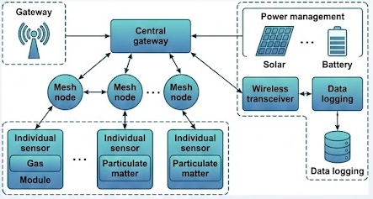
Figure 1: Detailed system architecture of the multi-node wireless sensor system, illustrating data flow, sensor integration, power management, and wireless connectivity.
References (Optional)

References
- T. Zhan, X. Shi, Y. Dai, X. Liu and J. Zi, “Transfer matrix method for optics in graphene layers”, J. Phys.: Condens. Matter, Vol. 25, pp. 215301, 2013.
- F. Capolino, Theory and Phenomena of Metamaterials, Taylor & Francis, London, 2009.

